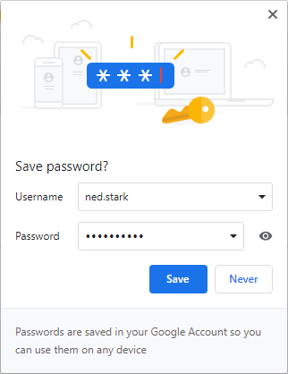
Remember/Forgot Password
Remember Password with Browser
Most browsers have the ability to save your Username & Password to make it quick and easy to log into the DCI Web Portal
This is available on most internet browsers (Google Chrome preferred) when you first log into your account or change your password.
Remember Password Process
- Navigate to the DCI Portal
  - acumen.dcisoftware.com
- Enter correct Username & Password
- Select Sign In
- Save Password box will pop up on screen (right)
- Confirm login was successful
- Select Save
- Username & Password will now be saved for future use

Forgot Password?
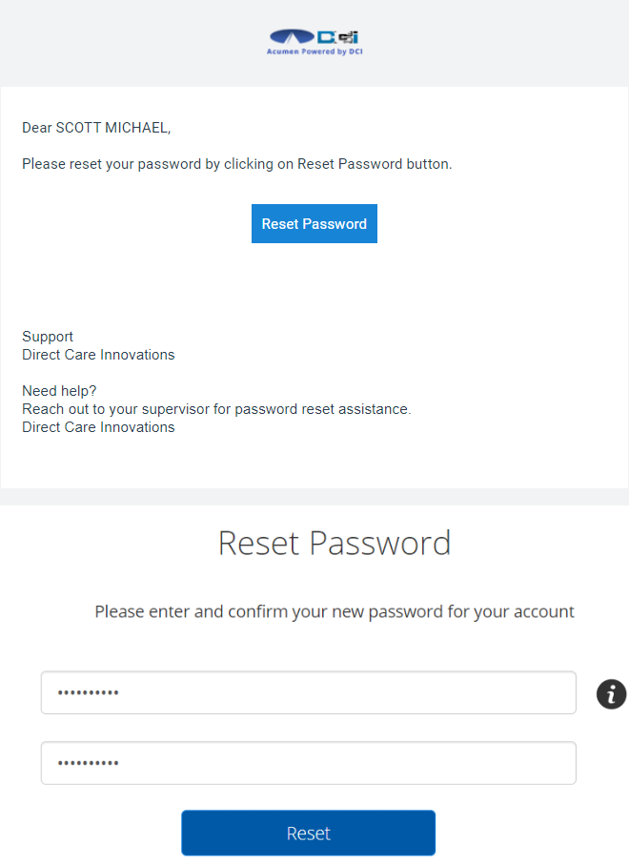
DCI also gives you the ability to reset your own password if it is lost or forgotten. As long as the user has a valid email on file, they can use the Forgot Password link below the Login screen. DCI will then send the user a Reset Password email to complete.
This email can also be sent by contacting your Acumen rep and request that we Reset Authentication Details.
Forgot Password Process
- Navigate to the DCI Portal
  - acumen.dcisoftware.com
- Select the Forgot Password link
- Open email linked to DCI profile
- Find the Reset Password email and open (right/top)
- Select Reset Password
- Enter new Password twice (right/bottom)
- Select Reset > Select Yes
- Save new password with the steps above
Your password has now been reset and saved.
For any questions or to learn more please contact Acumen Customer Service at (877) 211-3738 today!

